NLT

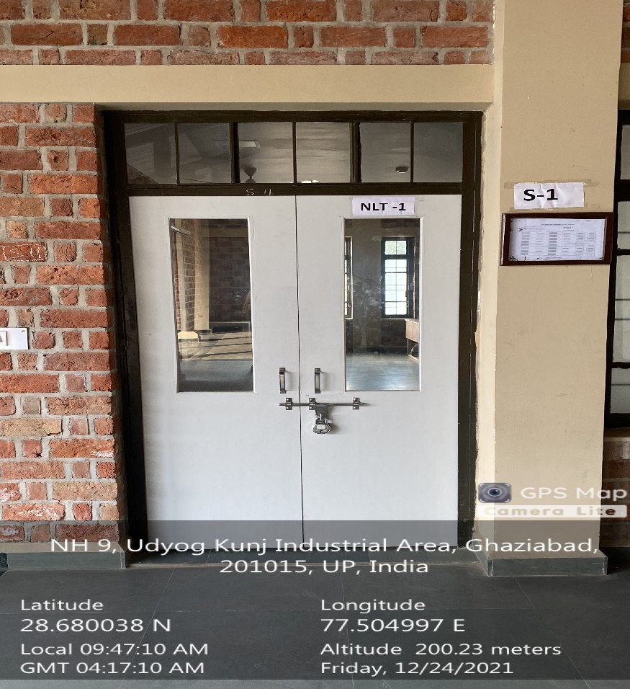

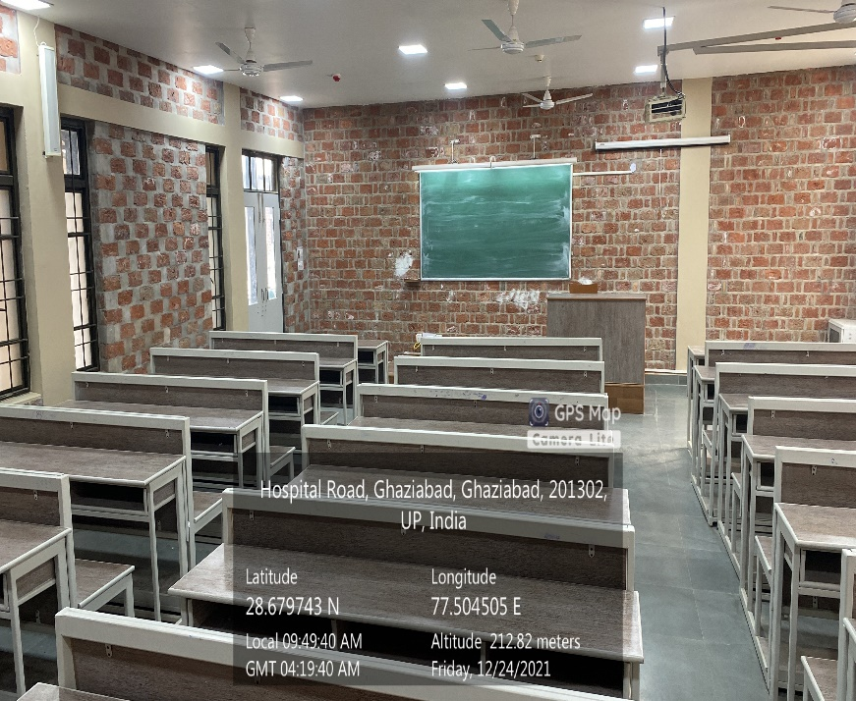

**NLT-1**

**(NLT Block, Ground Floor**

**Available Facilities: Green Board, Wi-Fi, Sound System, Projector)**

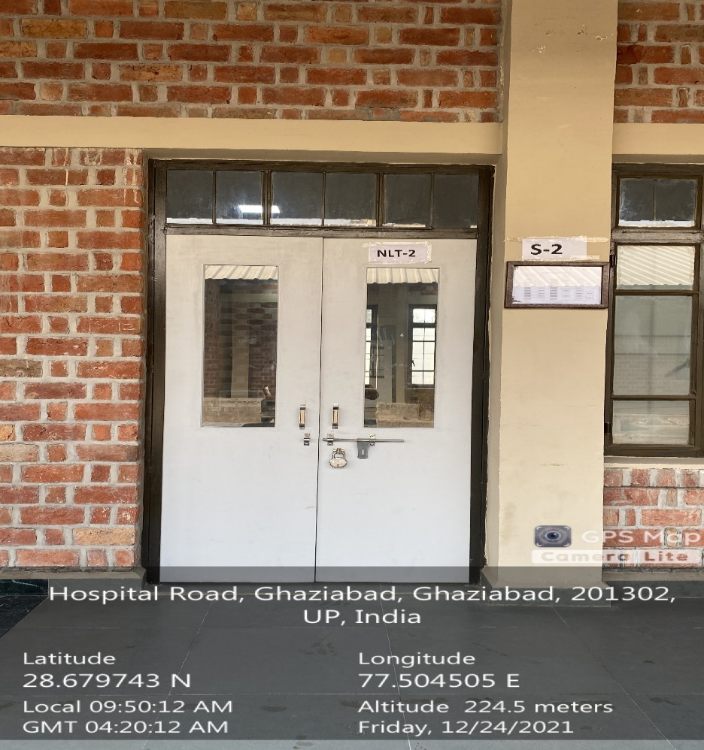

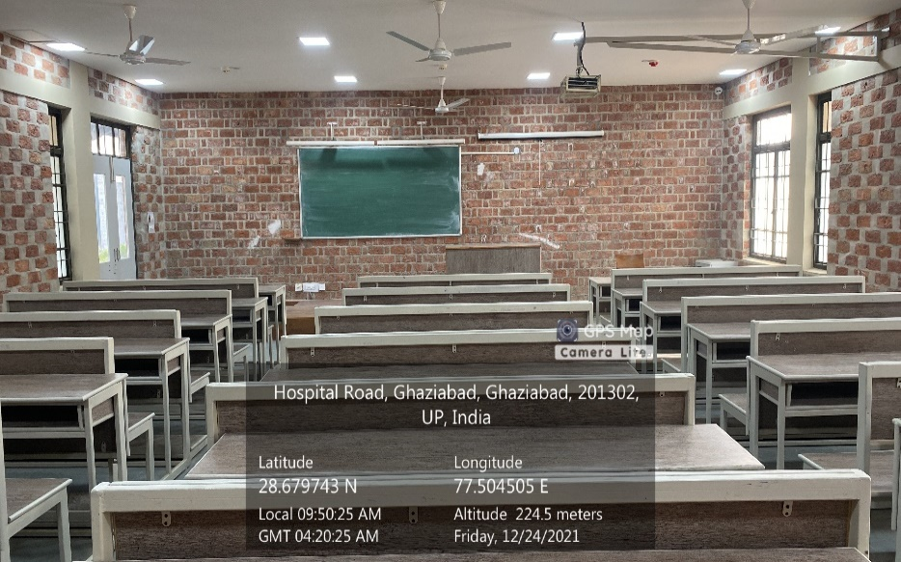

**NLT-2**

**(NLT Block, Ground Floor**

**Available Facilities: Green Board, Wi-Fi, Sound System, Projector)**

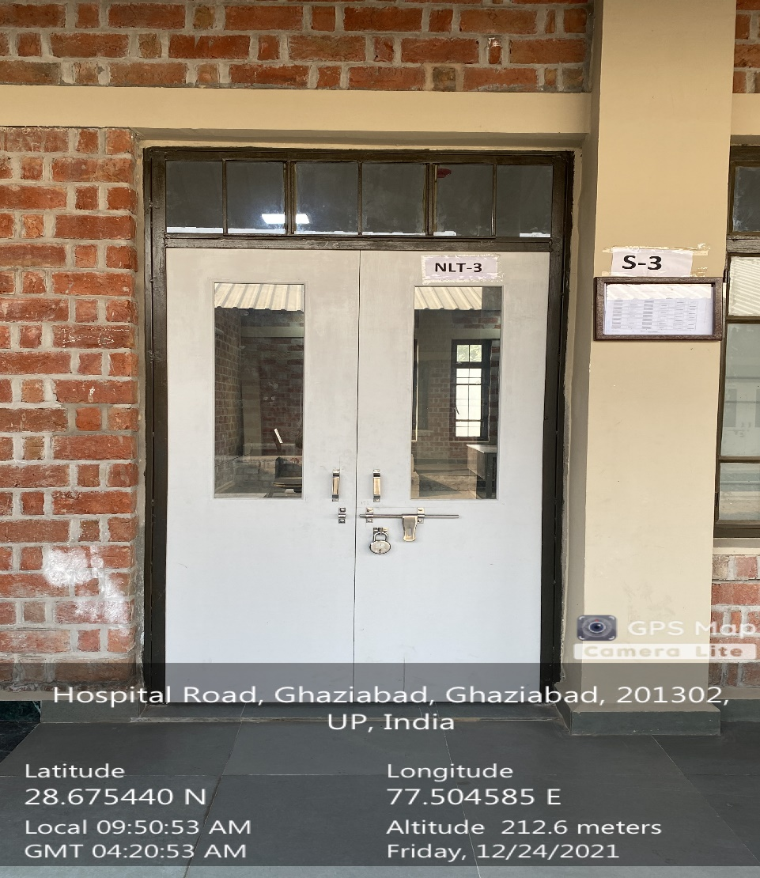

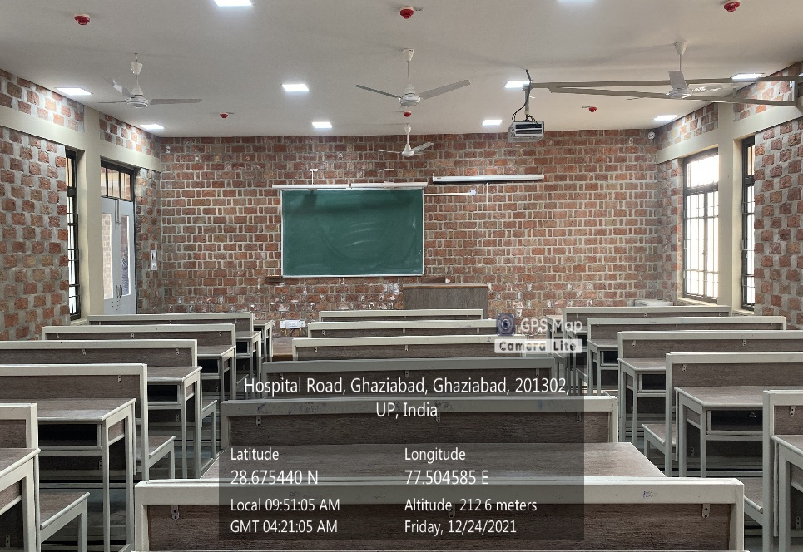

**NLT-3**

**(NLT Block, Ground Floor**

**Available Facilities: Green Board, Wi-Fi, Sound System, Projector)**

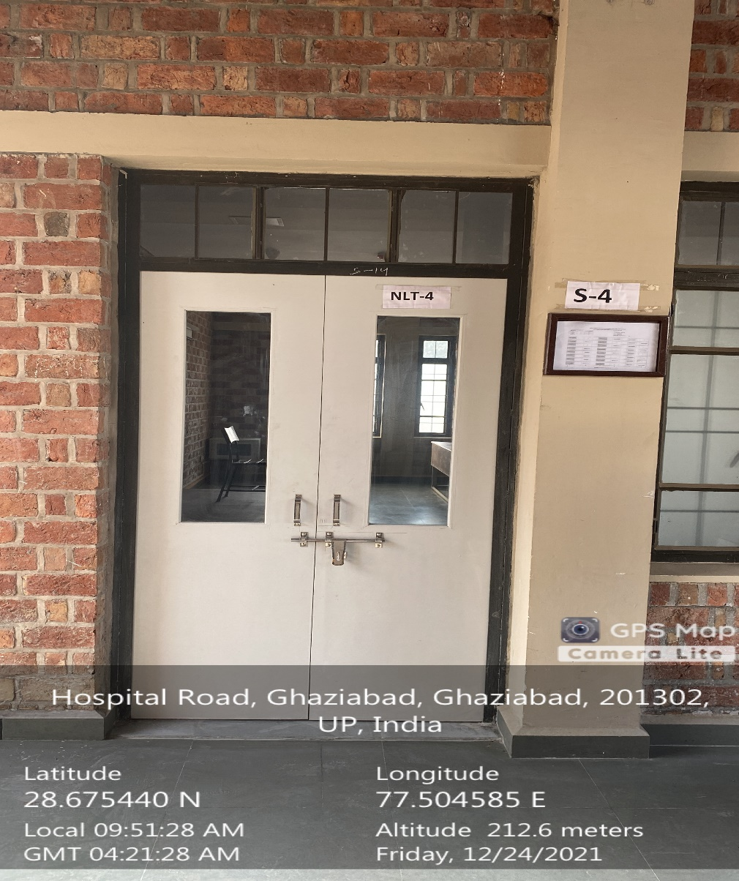

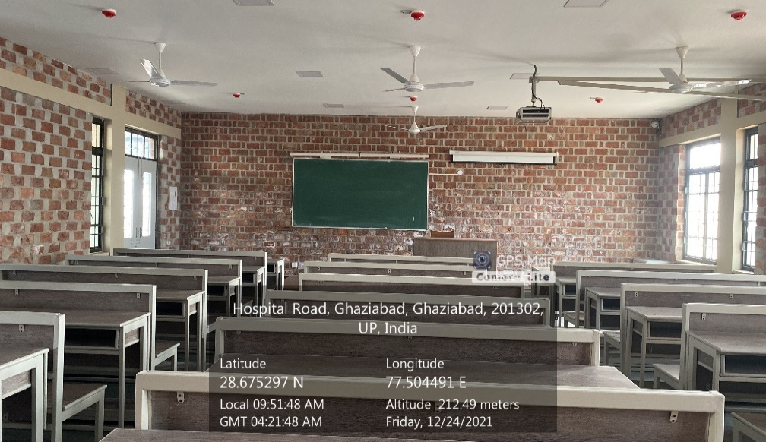

**NLT-4**

**(NLT Block, Ground Floor**

**Available Facilities: Green Board, Wi-Fi, Sound System, Projector)**

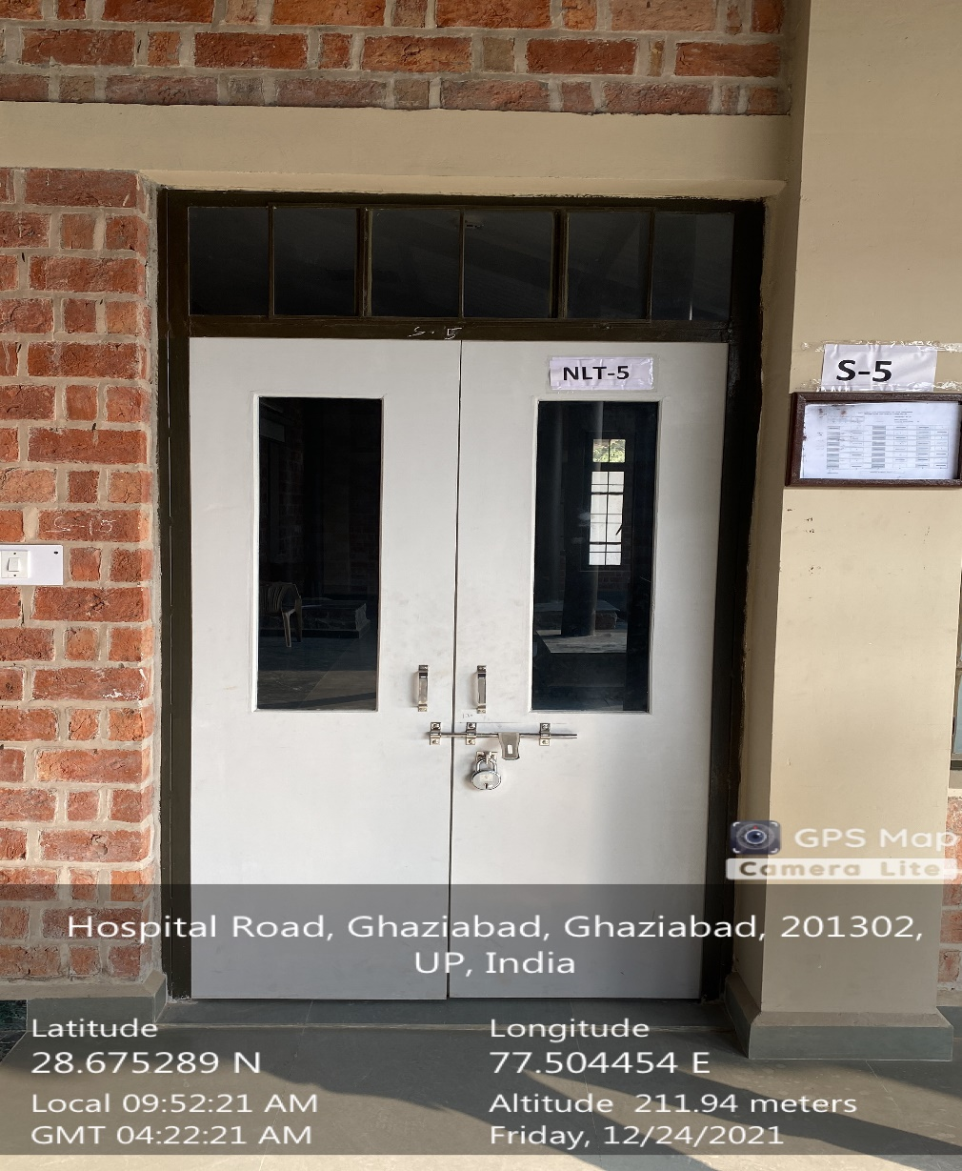

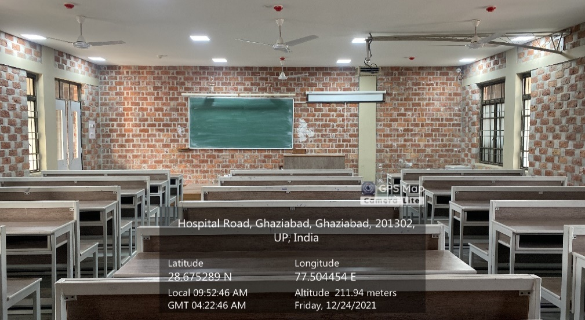

**NLT-5**

**(NLT Block, Ground Floor**

**Available Facilities: Green Board, Wi-Fi, Sound System, Projector)**

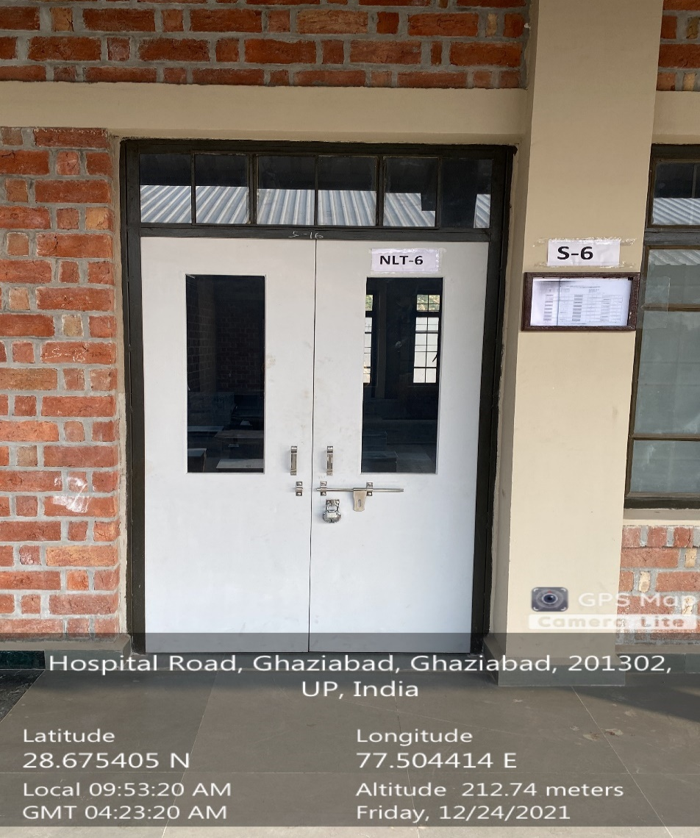

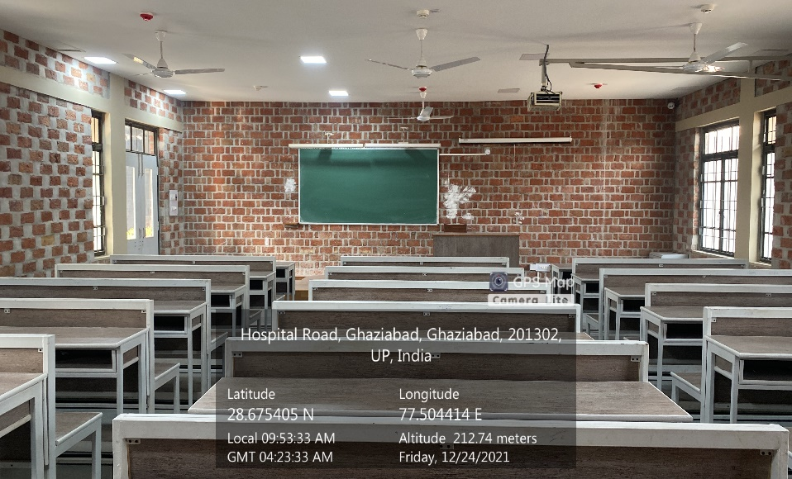

**NLT-6**

**(NLT Block, Ground Floor**

**Available Facilities: Green Board, Wi-Fi, Sound System, Projector)**

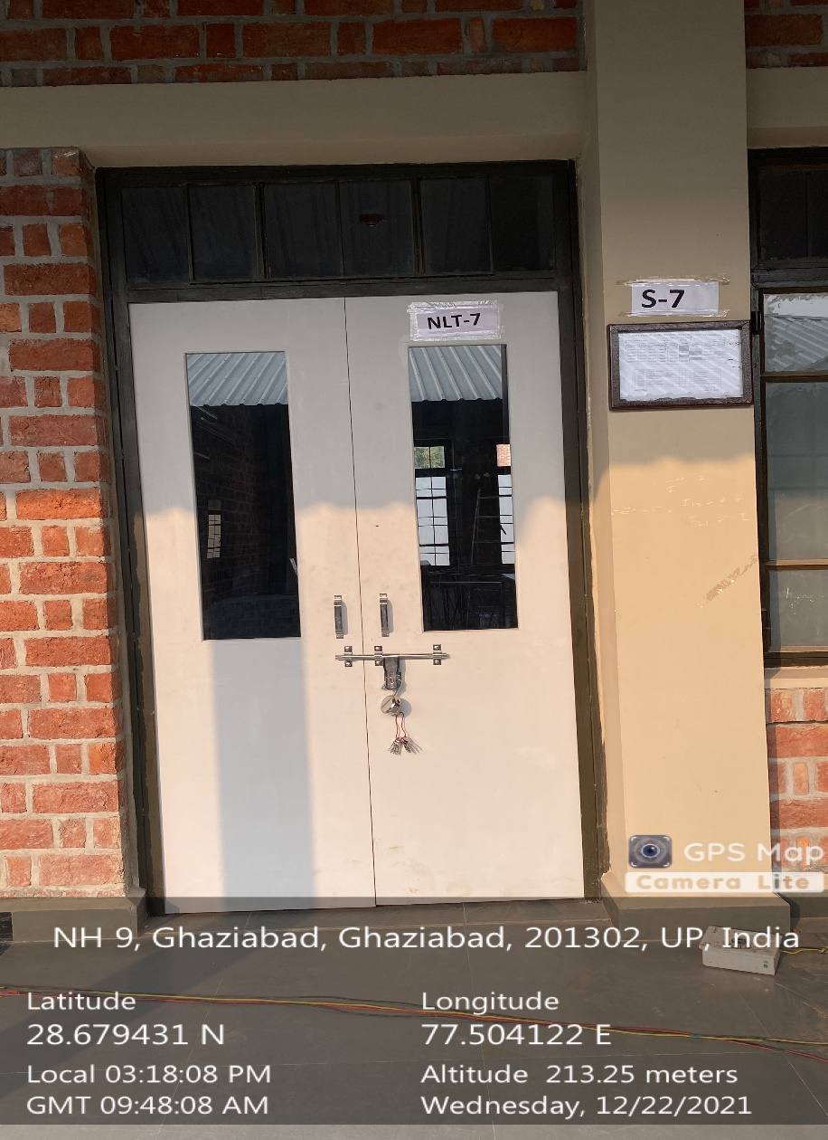

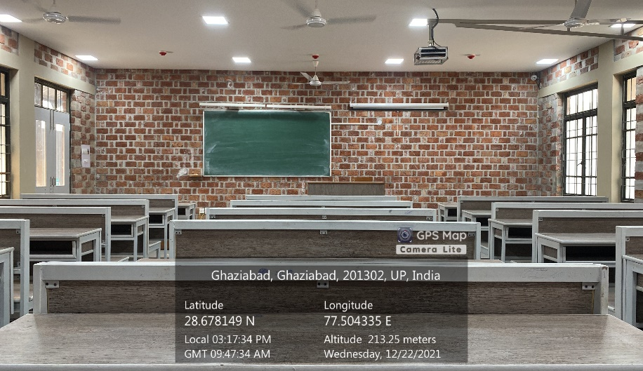

**NLT-7**

**(NLT Block, Ground Floor**

**Available Facilities: Green Board, Wi-Fi, Sound System, Projector)**

**TUTORIAL ROOMS**

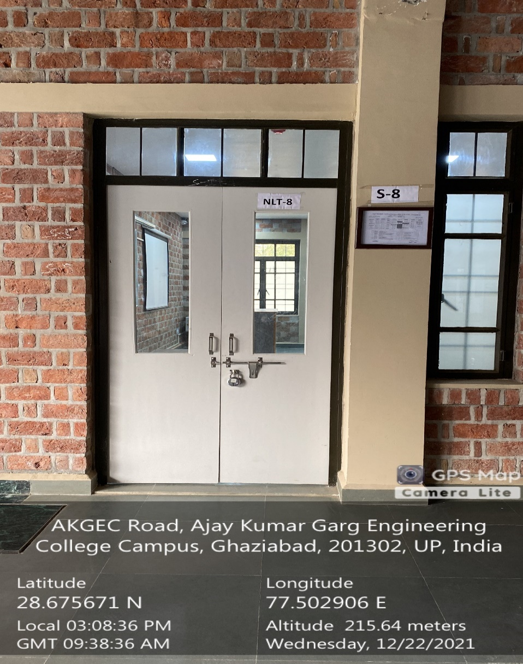

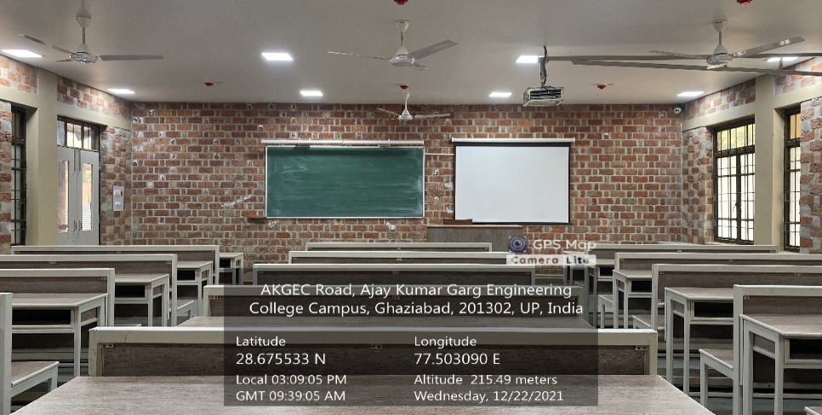

**NLT-8**

**(NLT Block, Ground Floor**

**Available Facilities: Green Board, Wi-Fi, Sound System, Projector)**

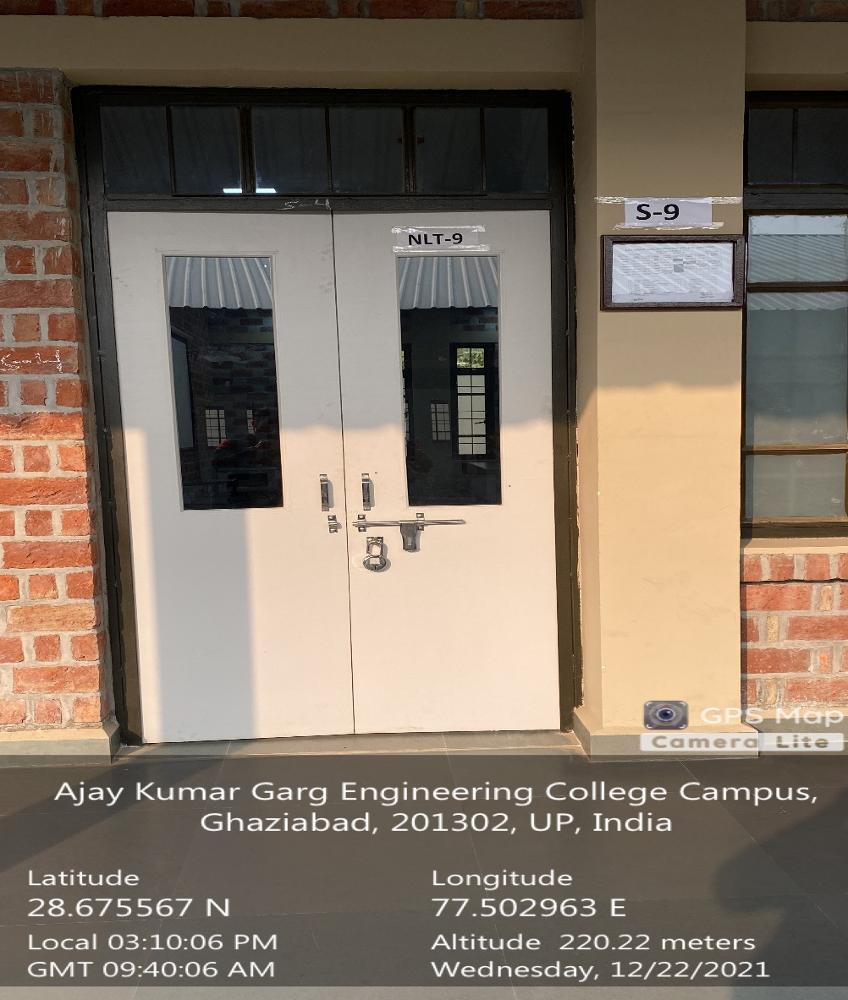

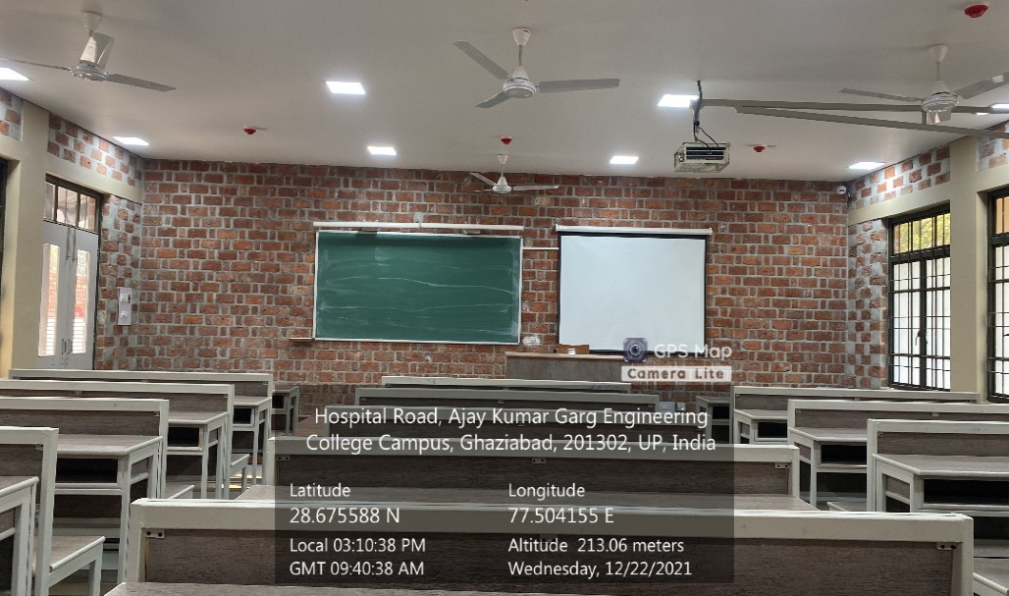

**NLT-9**

**(NLT Block, Ground Floor**

**Available Facilities: Green Board, Wi-Fi, Sound System, Projector)**

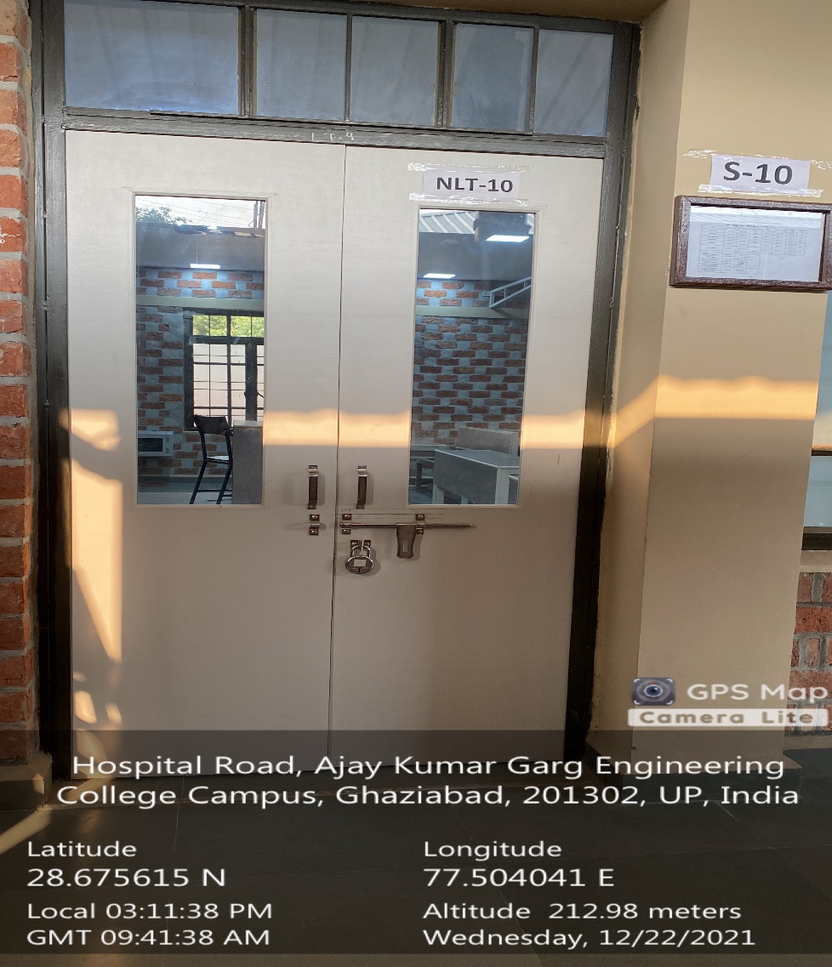

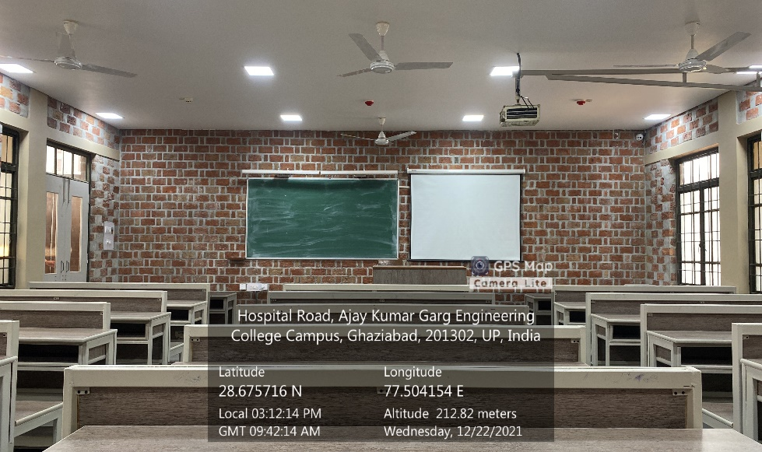

**NLT-10**

**(NLT Block, Ground Floor**

**Available Facilities: Green Board, Wi-Fi, Sound System, Projector)**

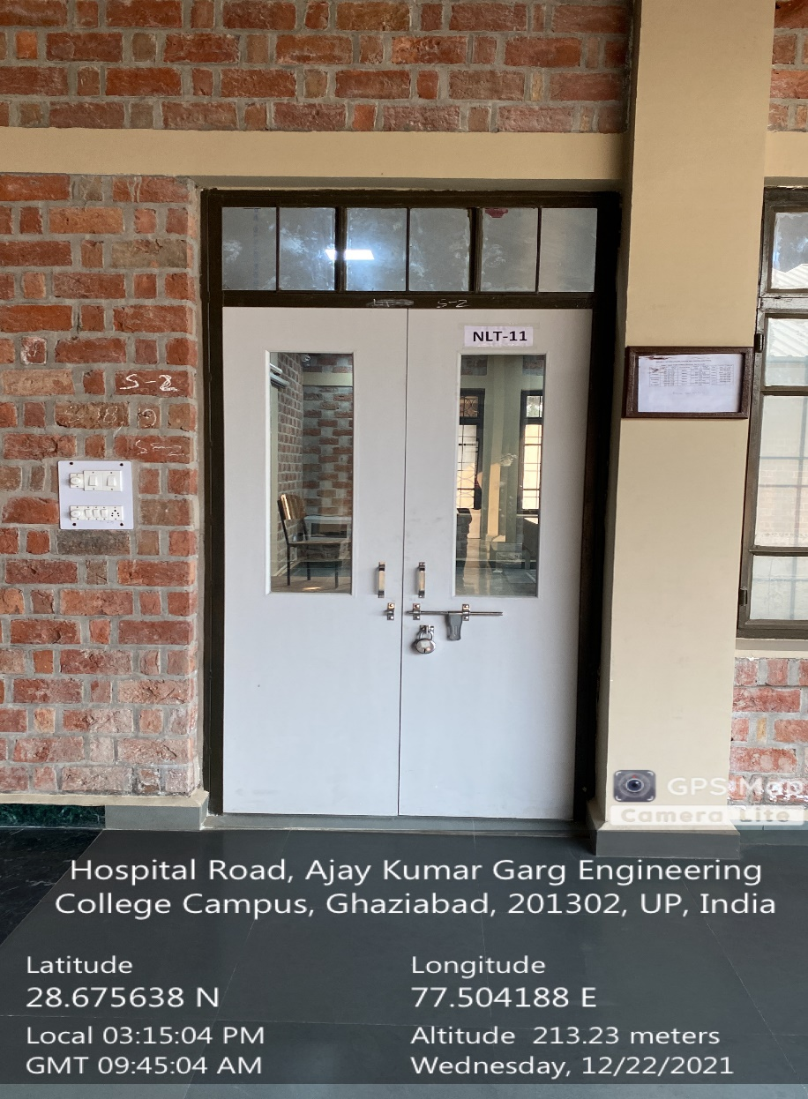

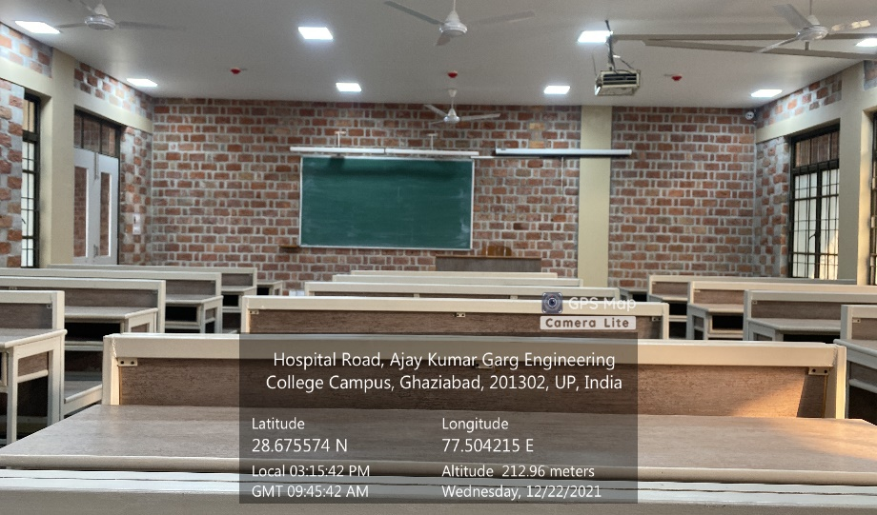

**NLT-11**

**(NLT Block, Ground Floor**

**Available Facilities: Green Board, Wi-Fi, Sound System, Projector)**

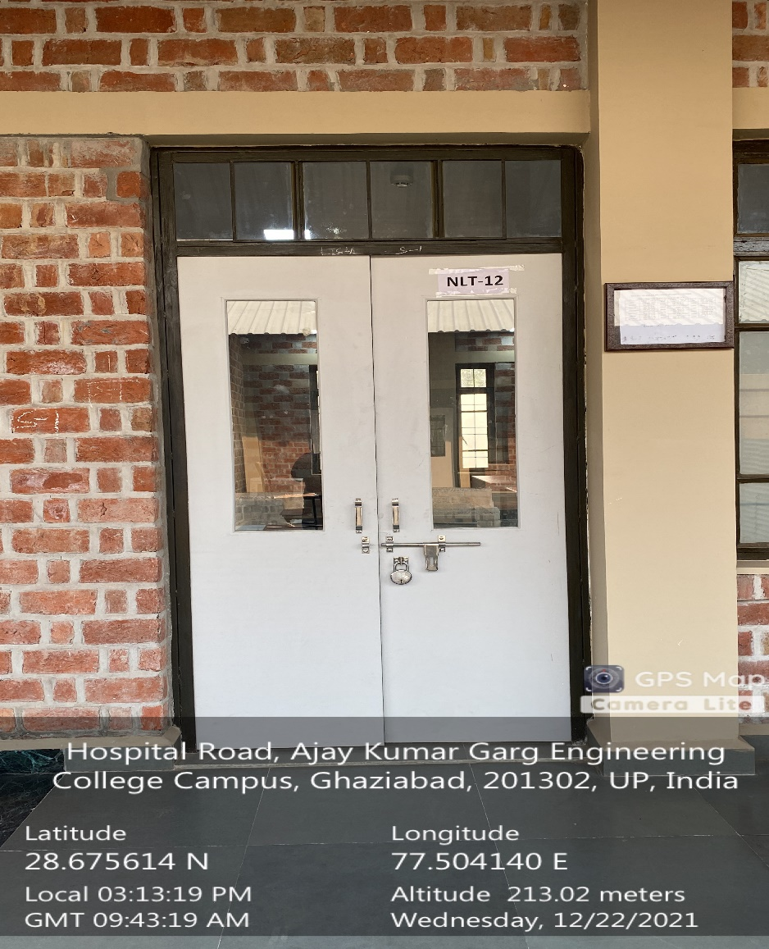

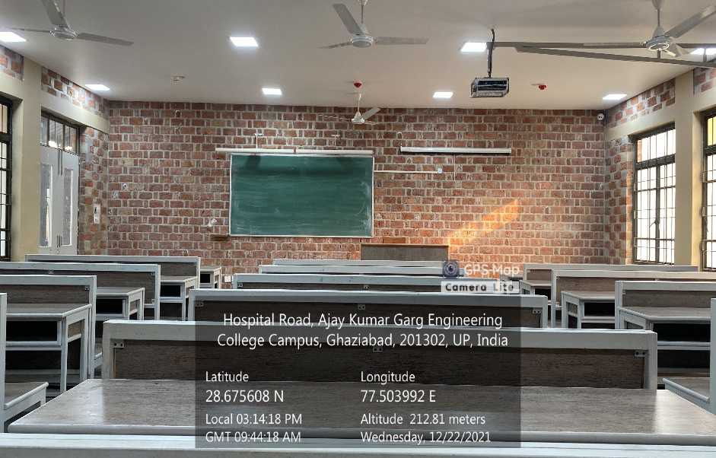

**NLT-12**

**(NLT Block, Ground Floor**

**Available Facilities: Green Board, Wi-Fi, Sound System, Projector)**